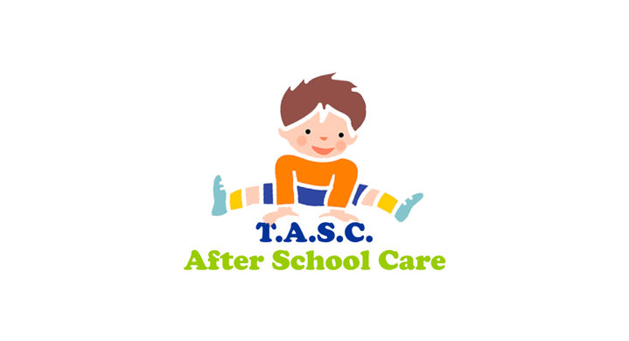**NEWSLETTER August 2024**

**CONTACT NUMBERS**

**Knightswood 950 2779 / 07585918074**

**St Ninians 950 2497 / 07901385999**

**Antonine 944 6868 / 07824427916**

**St Clare’s 07824390076**



Firstly, we would like to offer a huge welcome to all parents, new parents and of course all children who are coming back or just starting with us. We would particularly like to welcome all our new P1s. We are so glad that you have chosen T.A.S.C. as your childcare provider.

Please feel free to ask the staff any questions you may have as the staff are more than happy to help and advise you on what to expect when using the service.

**ABSENSES**

It is very important that you contact us and not the school if your child is off. You can text the service you use or leave a message on their machine. This is preferable to an email as the staff are part time and only come into the service at 2pm to prepare snacks and activities.

Can I also ask that you contact your service with any questions that you may have. We are now receiving a lot of emails with questions that are best answered by your service.

**LUMPS & BUMPS**

If your child has an injury you need to contact the service before they attend, to ensure that a risk assessment is in place. Failure to do so will mean you will be contacted, and your child will not be able to attend the service.

**OCTOBER SCHOOL HOLIDAY**

Booking forms can be found in our website site www.tascafterschoolcare.org.uk

Under the booking section, just completed both the booking form and permission slip and make your payment. There is no need a permission slip if you have used the holiday service this year. Unfortunately, we can’t except holiday bookings without all the forms completed and payment made.

During the holiday service we travel using your child ‘s bus passes. Can you please ensure that they have a travel pass. Further details to obtain this can be found on [www.mygov.scot](http://www.mygov.scot) Please search for Apply for an under 22 bus passes.

To avoid disappointment please be advised that this year’s summer service was busy and had a waiting list for some days. I would suggest that you book early and to avoid disappointment.

**ANTONINE**

Welcome back to all our boys and girls, we hope everyone had a great summer holiday and are glad to be back :)

Over the last couple of weeks, the children have taken an interest in bug hunting using some of our new equipment i.e. magnifying bug catchers, nets and trowels. Our plan is to incorporate SHANARRI into such activities and encourage the children to explore the green spaces and outdoors around us while discovering, identifying and classifying living things in our environment.

Please note - We will go to the park some days and will return for 4.20 so if you feel you may collect your child before then, drop us a little text or give us a call on our mobile.

Thanks, Kerri Anne

**KNIGHTSWOOD**

We would love to welcome all our boys and girls, and we would love to report that everybody has settled in well.

We have been going over the golden rules promoting then. This is to promote respect and friendship. We will organise activities including a short quiz promoting the golden rules and other activities that will support us to provide a welcoming and safe, friendly environment.

We are supporting safety within our environment and have been going over the fire drill to show the children what doors to leave by and what we should do in the event of a real emergency. We will be doing a drill every month and a few mock drills as well.

Amy has started our autumn wall, and this year with the help of some of our children they have decided on harry potter. Please keep an eye out for the completed masterpiece.

Lynda.

**ST CLARE’S**

St Clare’s have welcomed both new and P1’s into our service at the start of the new school year and we are happy to report that all are all settling in well with the help of their allocated Buddies. These buddies are responsible for giving the younger children support and guidance as they become part of our team.

We have crafted and designed our new Emoji’s, and this year we are also going to introduce a new ‘Token’ led incentive. This will require the existing group to start working not just individually, but as part of a team to achieve rewards and recognition and more importantly to feel included, which will be one of the key SHANARRI indicators that we will focus on.

Children have also been included within the forward planning of our up-and-coming activities, along with being responsible and part of making our ‘Golden Rules’ charter which we shall review each term throughout the school year.

Kerry

**ST NINIANS**

Just like to say it’s so lovely having everyone back. We hope you all had a lovely summer. We are working on our SHANARRI indicator**Included** this month whilst we welcome some new children into our St Ninians after school care family. We have our ‘everyone has a voice’ wall display, getting suggestions from the children about their likes and dislikes.

We are also making a room charter to help everyone to understand their rights and responsibilities, and how these can help keep everyone safe, letting the children suggest which ones they think suits us best.  There will be plenty of group activities available to help everyone feel included and get to know each other.

Fiona

**PARENTS SNACK & ACTIVITY SURVEY**

Can I ask you to support the service by completing this quick survey. This will help us to ensure we provide a service that takes into consideration parents thoughts and views.

https://s.surveyplanet.com/0ciorfyv

**OUTDOOR LEARNING**

Within all of the service, we will be continuing to base our learning outdoors, so please provide your children with appropriate clothing.

**FEES**

Always a difficult subject, but despite repeated requests some parents are constantly having to be ‘reminded about their fees. This is so unfair on the staff. The staff should not have to ask parents for fees for a service that they use. Fees are used to pay staff wages, so it would be appreciated that parents follow our fee policy, which can be found on our website. We will be enforcing our exclusion policy when fees are 2 weeks in arrears. Hopefully you will have been issued with a spreadsheet to allow you to keep track of your payments. Fees are due until the school term end even if you go on holiday prior to this date. Fees are also due when your child is of sick, attending a school club or when the school is closed through no fault of the service. There is now a £10 charge per week for parents that have not paid their fees.

**STUDENTS FEES**

To use the service, students are required to follow our fee policy, the same as our other users. Fees are required for all weeks, as we do not employ staff and then drop their hours etc.

Students are responsible for ensuring their fees are paid. Please be aware that our contract is with the student and not with their further education establishment.

**SOCIAL MEDIA**

Please remember to join us on FACEBOOK. You can check out our website on

[www.tascafterschoolcare.org.uk](http://www.tascafterschoolcare.org.uk/)

where you can be kept up to date with all the latest activities and information including dates for your diary, policies, bookings and links to sites that you may find useful.

Christina

Service Manager